PROJECT REPORT


Project Title: Smart Traffic Simulation
Session: 2023-2027
(Reg No. 2023-UOK-045041)
(Reg No. 2023-UOK-04519)
Submitted To: Sir Bilal Ahmed
Subject: Computer Network
Submitted By: Arooj Yasin &
Quratulain Ashqaf
Date of Submission: Dec 3, 2025
DEPARTMENT OF DATA SCIENCE
FACULTY OF COMPUTING AND ENGINEERING
UNIVERSITY OF KOTLI AZAD JAMMUA AND KASHMIR

Abstract:
The Smart Traffic Simulation project aims to control traffic flow using IoT devices and a network setup. It uses Cisco Packet Tracer to build a LAN/Wi‑Fi topology with sensors, a server, and IoT actuators. The network connects a smartphone, webcam, and traffic sensors to a central office server & cloud. IP addresses are assigned to enable communication between devices. Testing with ping verifies connectivity & traffic‑control logic. The simulation shows successful IoT‑based traffic management with real‑time monitoring.
Introduction:
The project idea is to manage traffic signals intelligently by integrating IoT sensors with a network infrastructure. Networking is crucial because it lets devices (sensors, actuators, servers) exchange data for automated decisions. In the real world, this can be applied to smart city traffic management, reducing congestion & improving safety.
Objectives:
1. Understand LAN/Wi‑Fi communication – learn how devices talk in a local network.
2. Assign & configure IP addresses – set static IPs for all devices in the topology.
3. Perform testing using ping command – verify end‑to‑end connectivity & troubleshoot.
Tools & Software Used:
Tool Version Purpose
Cisco Packet Tracer 8.2.1 Network simulation & IoT design
Windows OS 10 Host environment for Packet Tracer
Network Topology:
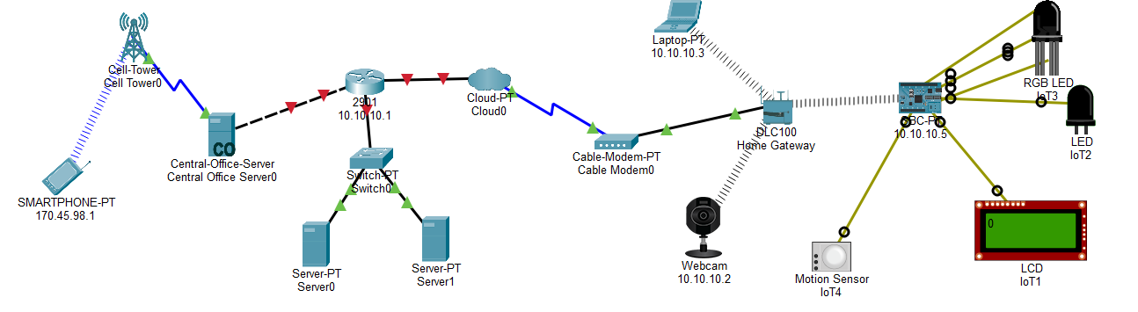
Device List:
Device Name Purpose
Smartphone-PT Sends control commands via cellular
Central-Office-Server Manages IoT data & logic
Switch0 Connects internal LAN devices
Cable Modem0 Provides internet access to home gateway
Home Gateway (DLC100) Routes traffic to IoT devices
Webcam Streams video for traffic monitoring
Motion Sensor (IoT4) Detects vehicles & triggers signals
LCD (IoT1) Displays traffic status
RGB LED (IoT2) Acts as traffic light indicator
Implementation Steps:
1. Build the topology in Packet Tracer as shown.
2. Assign IPs to each device (e.g., Smartphone 170.45.98.1, Webcam 10.10.10.2).
3. Configure the server with IoT services & routing.
4. Connect sensors (Motion Sensor) to the gateway & program logic for traffic control.
5. Link IoT devices (LCD, LED) to the gateway for output.
Simulation & Testing:
Run ping from Smartphone to Webcam & IoT devices to check connectivity.
Example command: ping 10.10.10.2 (from Smartphone).
Observation: All pings should be successful, showing the network routes packets correctly.
Results & Discussion:
Success: IoT devices communicate & control traffic signals as intended.
Challenges: Configuring IoT module logic & IP routing.
Solutions: Double‑check IP schemes & use Packet Tracer’s “simulation” mode to trace packets.
Conclusion:
The project taught LAN/Wi‑Fi networking, IoT integration, and traffic‑management logic. Future improvements could include adding more sensors, AI‑based decision making, or integrating with a real cloud platform.
References:
Here are some references for such a project:

1. Cisco Packet Tracer – the software used to create this simulation; it’s widely used for networking labs and projects involving routers, switches, and IoT devices.
2.Online resources – Youtube , Google and AI tools
3.Classroom lectures Notes
GitHub Upload Project:
